FY 2005 OPERATIONAL PLAN
Upper Cook inlet Salmon personal use harvest monitoring
Principal Investigators: | Robert Lafferty, Fishery Biologist III
 | Kirk Brogdon, Analyst Programmer V
Assisting Personnel: | Pat Hansen, Biometrician III
 | Margaret Nussbaum, Administrative Clerk III
 | Diane Novinska, Administrative Clerk II
 | Kimber Amundson, Administrative Clerk II

Title Approval Signatures Date
Project Manager ________________________________________________
Co-project Manager ________________________________________________
Project Biometrician ________________________________________________
Area Manager ________________________________________________
Research Supervisor ________________________________________________
Biometric Review ________________________________________________
Regional Supervisor ________________________________________________
Table of Contents
Page
List of Tables ii
List of Figures ii
List of Appendices ii
SYNOPSIS 1
Need 1
Benefits 1
Objectives 1
Procedures 1
Location 1
Budget Summary 2
INTRODUCTION 3
OBJECTIVEs 4
STUDY DESIGN 5
DATA COLLECTION 7
DATA REDUCTION 8
DATA ANALYSIS 10
SCHEDULES AND REPORTS 12
LITERATURE CITED 13
Appendix A - 2005 Upper Cook Inlet personal use Salmon Fishing Permit 16
Appendix B -Reminder letter to be mailed to nonrespondents 18
Appendix C - Cook Inlet personal use Fishing Regulations, 2005 21
APPENDIX D - KEYPUNCHING INSTRUCTIONS 23
APPENDIX E - FILE STRUCTURE FOR PERSONAL USE SALMON DATABASES 32

List of Tables
Table Page
1. Number of permits issued and response rates by mailing, 2000-2004. 14
2. Salmon harvests, standard errors and relative precision in Upper Cook Inlet Personal Use Fisheries, 2000-2004. 15

List of Figures
Figure Page
1. Number of personal use permits issued in Upper Cook Inlet in 1996-2004 . 4

List of Appendices
Appendix Page
A1. 2005 Upper Cook Inlet personal use salmon permit. 17

B1. Reminder letter to be mailed to nonrespondents. 19

C1. Cook Inlet personal use fishing regulations, 2005. 21
D1. Keypunching Instructions. 24
E1. File structure for personal use salmon databases. 33

SYNOPSIS

Need
Collecting and monitoring fishery harvest and participation information is essential in meeting the Department’s statutory mandate for sustainable fishery management. Harvest and participation in the commercial and sport fisheries are measured via fish ticket and annual postal survey, respectively. However, personal use fisheries are classified differently because harvest methods are not historically similar to sport fishing nor are harvests commercial sold. To compensate a permit process was incorporated into a management plan by the Board of Fisheries to monitor harvest and participation in the Upper Cook Inlet (UCI) salmon personal use fisheries. Alaskan household permits allow resident family participation in the set gillnet fishery near the Kasilof River and dipnet fisheries located in lower areas of the Kasilof and Kenai Rivers and Fish Creek. Recent salmon harvests in UCI personal use fisheries had exceeded 350,000 salmon. The UCI Personal Use Salmon Management plan governs permit requirements, fishing areas, dates, gear and harvest limits. Effective in 2005, the Board of Fisheries granted the harvest of flounder under this salmon permit. This project estimates and reports 2005 UCI personal use salmon and flounder harvest and participation by fishery.

Benefits
This budget supports staff to administer the permit process, estimate participation and harvest, and reporting. These assignments encompass the following jobs: permit drafting, duplicating and distributing permits, mailing and phone costs for reminder notices, staffing to keypunch permit data, and staffing for analysis and reporting of participation and harvest information.

Objectives
- Estimate harvested salmon by fishery and gear type;
- Estimate the number of households participating by fishery; and
- Estimate the incidental harvest of flounders by fishery.

Task
Provide harvest permits to eligible Alaskan households who wish to participate in Upper Cook Inlet personal use fisheries.

Procedures
In accordance with personal use fishery regulations, participants must possess a permit to record their salmon and flounder harvest under personal use regulations in Upper Cook Inlet fisheries. Permit holders agree to return their permit by mail to Fish and Game by 15 August. Forgetful permit holders are sent a courtesy reminder to return their effort and harvest information on their permit to the Department. A second courtesy reminder is mailed to non- respondents of the first reminder. Data from returned permits will be keypunched, edited, processed and archived. Additionally a summary report will be published providing estimates of participation and salmon harvest by fishery and gear type.

Location
Project coordination is from the Anchorage office, however, permits collect harvest and effort information from Upper Cook Inlet personal use fisheries in the Kasilof River, Kenai River, and Fish Creek (near Wasilla).

Budget Summary
Code | Line Item | Cost
100 | Personal Services | 42.9
200 | Travel | 0
300 | Contractual | 15.0
400 | Commodities | 0
500 | Equipment | 0
700 | Grants | 0
Total |  | 57.9

Budget Manager: Robert Lafferty, Fishery Biologist
Project Personnel: (Name, job class, months budgeted)
Kirk Brogdon | Analyst Programmer V | 1.0
Diane Novinska | Administrative Clerk II | 2.0
Kimber Amundson | Administrative Clerk II | 4.0
Robert Lafferty | Fishery Biologist III | 2.0
Total |  | 9.0

INTRODUCTION
Prior to the state’s subsistence priority law in 1978, individuals could meet their needs for fish under the subsistence fishing regulations in Cook Inlet. Court actions changed the definition of subsistence in 1978 and precluded some from participating in customary and traditional subsistence fisheries. The Board of Fisheries (BOF) countered these court changes by creating a new fishery class called “personal use” in areas that have a surplus of salmon beyond escapement, subsistence, commercial and sport needs. The intent of personal use fishing regulations are to permit the taking of fish when that take does not jeopardize the sustained yield of the resource and does not negatively impact an existing resource use or is in broad public interest (Alaska Administrate Code (5 AAC 77.001)).
With the establishment of area personal use fisheries, management plans and regulations governing harvest opportunities were implemented to ensure salmon harvests are sustainable. Harvest monitoring is essential for sustained yield salmon management.
There are four personal use salmon fisheries that occur in Upper Cook Inlet (UCI) above Anchor Point:
- gill netting at the mouth of the Kasilof River from 15 June through 24 June,
- dip netting at the mouth of the Kasilof River from 25 June through 7 August,
- dip netting at the mouth of the Kenai River from 10 July through 31 July, and
- dip netting at the mouth of Fish Creek opened by emergency order only.
A single permit authorizes resident participation in all four fisheries. This permitting process identifies an Alaskan household and assigns a uniquely numbered harvest record. Permit regulations require returning the harvest record to the Department by a specified date. A permit holder may obtain their annual limit of 25 salmon per head of household and 10 additional salmon per listed dependent. Each household permit is allowed the incidental take of 10 flounders. Since 1996, both permits issued and salmon harvest in the personal use fisheries in Upper Cook Inlet have increased to approximately 22,000 permits (Table 1) and harvests exceeds 350,000 salmon (Table 2).
The timing of these personal use fisheries capitalizes on sockeye salmon abundance. Often sockeye salmon comprises more than 95% of the total salmon harvest in the personal use fisheries of Upper Cook Inlet (Table 2). With few exceptions, participants are allowed to harvest all species of salmon, but Chinook salmon must be released in the dipnet fisheries of the Kasilof River and Fish Creek. The harvest of only one Chinook salmon per permit is allowed in the Kenai River dipnet fishery. Effective in 2005, the Board of Fisheries granted the harvest of flounder under this salmon permit with a household limit of ten flounder. Methods, means, dates and period duration are in regulation to provide predictable fishing opportunities (5 AAC 77.540). Additionally, managers possess authority to increase or decrease fishing time or area in times of above average or below average returns for conservation purposes. Nelson et al. (1999) provides a historical perspective of personal use salmon fishery development in Upper Cook Inlet.

OBJECTIVEs
- Estimate participation (household days fished) in each of the four personal use fisheries. All estimates of participation will be within 5% of true value 95% of the time.
- Estimate sockeye salmon harvest in each of the four personal use fisheries. Estimates of sockeye salmon harvest from the Kasilof dipnet, Kenai dipnet, and the Kasilof gillnet fishery will be within 5% of true values 95% of the time. Estimates from the Fish Creek dipnet fishery will be within 20% of true values 95% of the time.
- Estimate Chinook salmon harvest in the Kenai dipnet and the Kasilof gillnet fishery. Estimates of Chinook salmon harvest will be within 10% of true values 95% of the time.
- Estimate coho salmon harvest in the Kasilof and Kenai dipnet fisheries. Estimates of coho salmon harvest will be within 15% of true values 95% of the time.
- Estimate pink salmon harvest in the Kasilof and Kenai dipnet fisheries. Estimates of pink salmon harvest will be within 15% of true values 95% of the time.

In addition to the above objectives the following task will also be completed in 2005:
Estimate the incidental harvest of flounder in each of the four personal use fisheries.
To accomplish the above objectives and task we will print and distribute adequate numbers of personal use permits so Alaskan households may participate in Upper Cook Inlet personal use fisheries.

Reimer and Sigurdsson (2004) reported positive growth in participation in UCI personal use fisheries during six of the seven years, with annual growth varying from 2% to 10% during the years of 1996-2003. Growth in participation continued to increase by 12% with 21,900 permits being issued in 2004 (Figure 1). The anticipated demand for personal use permits in 2005 may exceed 25,000 permits.
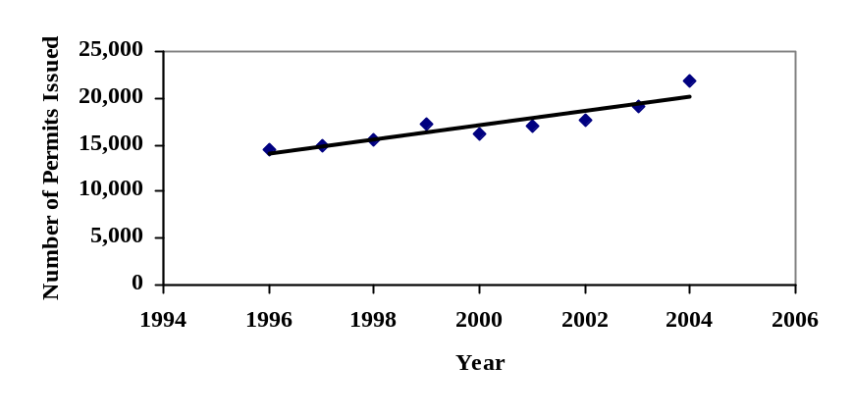
Figure 1. Number of personal use permits issued in Upper Cook Inlet in 1996-2004.

STUDY DESIGN
Area license vendors issue household permits to Alaskan residents who whish to participate in the Upper Cook Inlet salmon personal use fisheries. Previous year’s vendors in the Mat-Su, Anchorage, and Kenai Peninsula will be contacted to determine if they desire to continue issuing permits in 2005. Permits will also be available at Fish and Game offices in Palmer, Anchorage, Soldotna, and Homer. Permit quantities sent to vendors will be based on the number of permits issued in 2004. The total number of permits issued is a crucial number for proper harvest and participation estimation; therefore, the project manager is responsible for maintaining accurate records and providing these data to processing staff and the project biometrician. The permit actually has two components: the top half or vendor copy that contains the permit holder’s address and license information and bottom half is the participant’s harvest recording document that must be in possession while participating in the fishery. Permit halves are returned to the Department at different times. License vendors and Department offices return the top portion of the permit (vendor copy) to Research and Technical Services (RTS) in Anchorage for key punching on a monthly basis. Information to be keypunched from the top portion of the permit includes: permit number, permit holder’s name and address, sport license number, driver’s license number, the number of household members and allowable harvest (Appendix A). This information will be utilized to contact permit holders that have not returned the bottom half of the permit with their harvest and participation information. One of the conditions of the permit requires households return their permit by August 15, 2005.
Unfortunately, a few vendors will fail to return some top portions of issued permits. Overall, there are fewer than 100 vendors issuing permits, so it will be possible to contact vendors during the season and at the end of the season to minimize the loss of permit holder contact information. Additionally, permits issued to vendors will be cataloged in sequential order. If a vendor fails to return issued permits, the project biologist will be able to determine which vendor to contact. If we fail to receive all the vendor copies, the number of permits issued will be estimated. Some permit holders will return their permit without a corresponding vendor copy. These are considered orphan permits. Because we rely on the vendor copy to determine the number of permits issued by a given vendor, the permit number on the orphan permits will be used to identify a vendor with incomplete permit returns. Assuming that the response rate, prior to the first reminder letter, among known permits from a vendor will be the same as the response rate among orphan permits, this response rate will be applied to the orphan permits to estimate the total number of permits issued by the identified vendor with incomplete permit returns. In the past, we receive approximately 50 orphan permits a year.
Prior to 2001, the Department paid vendors to issue permits, but reimbursements became cost prohibitive with permit accounting, staff time, and administrative procedures. An explanation letter was sent to vendors ascertaining if vendors desired to continue issuing permits. Few vendors declined and the number of vendors participating in issuing permits has remained stable.
Permit holders must record their participation and harvest by day on the permit and return the permit to RTS by 15 August 2005. Permit holders who do not return their permits will receive up to two courtesy reminders. A reminder letter and permit copy will be mailed to non-respondents by September 29, 2005 and again a month later to those permits holders that have not responded to the first reminder notice (Appendix B). A hiatus of four weeks was considered appropriate to allow non-respondent permit holders to reply.
Rates of household permit returns have been consistent during the past five years. Fifty percent (50%) of the permit holders return their permit without a reminder notice. The addition of courtesy reminders improves permit return rate by an average of 19% with the first mailing and 12% with the second mailing (Table 1). The expected number of permits to be issued in 2005 is approximately 25,000. Approximately 12,500 households are expected to return their permit by the 15 August reporting deadline. Accordingly, about 12,500 households will be sent a reminder letter by September 29, 2005. Approximately 6,000 second reminders will be sent to households during the end of October. The anticipated number of permit returns and responses after two mailings is 20,250, with a total return rate of 81% (Table 1).
In 1997 the department used four mailings to investigate non-response bias of personal use permits. Estimated harvest and standard error of sockeye salmon narrowed after the returns from the first reminder mailing and then remained stable with remaining mailings two through four, except for the Kasilof dip net fishery. The harvest estimate for each fishery did not significantly change after incorporating responses from the second mailing.
Beginning in 1998, two reminders have been mailed to forgetful permit holders. All participation and harvest information reported by permit-holders who promptly return their permits and those permits returned before the second reminder letter will be treated as a census of “compliant” households. Information obtained by permit-holders who return their permits after the second reminder letter is mailed will be treated as a sample of “non-compliant” households.
Estimates of participation and harvest by non-compliant households will be obtained by first calculating the mean participation (household days fished) and harvest of each species for all households that return completed permits after the second reminder mailing. Mean estimates will be expanded to include all non-respondents.
Total estimates of participation and harvest by species for each fishery will be obtained by summing the estimates for the non-compliant households with the corresponding information obtained from permits returned by the compliant households.
Information from the 2000-2004 personal use permit-holders (Table 2) was used to predict the sampling variances and related levels of relative precision. If 2005 return rates remain high, then the precision levels should well exceed the desired objective criteria listed in the objectives.
As noted above, the levels of precision achieved by this project have been substantially better than the objective criterion. Two causes for the high precision are:
- the assumption that about 50% of permit holders will comply with the reporting deadline, these households account for more than 50% of the harvest, and this component of the total harvest estimate is measured with no sampling error; and
- issuing reminders to all non-compliant households leads to relatively precise estimates of this component of the harvest.
As such, the precisions that we expect for the 2005 survey may not be as good as predicted if any of these factors change dramatically.
Issuing reminders to all non-compliant households is not directed at obtaining the goal objective criteria, but rather to ensure that all households with personal use permits are treated equally (so that each household is given the same opportunity to comply with reporting requirements prior to the 2006 season).

DATA COLLECTION
All Alaskan households with a valid Alaska resident sport fishing license, as well as those who are exempt from licensing (PID), qualify to receive a permit. All listed household members are eligible to participate under their household permit.
Permits will be issued at Fish and Game offices in Anchorage, Soldotna, Palmer, and Homer. Permits also will also be issued by vendors in the Mat-Su, Anchorage, and Kenai Peninsula area who issued Cook Inlet personal use permits in 2004. New vendors may request to issue Cook Inlet personal use permits. Permits (Appendix A1) are sequentially numbered and perforated horizontally across the middle. Identifying information (permittees name, address, telephone number, sport fishing license number, total number of household members, total household salmon harvest limit and Alaska driver’s license number) will be completed on the top half of the permit. The number of household members and their names will also be recorded on the bottom half of the permit at the issuing office or license vendor. The issuing officer will write the total household salmon harvest limit on both halves of the permit, and sign the top half. The applicant will also sign the top half of the permit. The Department or the license vendor will retain the top half (the vendor copy) of the permit with the identifying information. The bottom half will be issued to the permittees. License vendors will be given post-paid envelopes to use to mail the vendor copies of their issued permits to RTS each month. They will be asked to return all vendor copies and unused permits to RTS by mid September. Vendors will be sent a letter and then contacted by phone or in person after the fishery closes in the beginning of August to remind them to send in their vendor copies.
Permit holders will record all fishing activity by their household on the permit, including which fishery, dates fished, salmon harvest by species and flounder harvested (if any). A check box is also provided for households that did not participate. When the permit holder’s household completes fishing, they will return the permit to Fish and Game, either by hand-delivery to a Fish and Game office or by attaching postage and mailing it to the address printed on the back of the permit.
Vendor copies will be keypunched during the summer. As completed permits are returned, harvest and effort information from them will also be keypunched. These completed permits will be marked as returned in the database.
Non-respondents will be identified and the first reminder letter (Appendix B1) will be mailed by September 29, 2005. Non-respondents to this first mailing will be identified and a second reminder letter will be mailed to the non-respondents by October 27, 2005.
In the rare chance more than one permit has been issued to an individual or household, the name, address, sport fishing license and or driver’s license number will be used to detect multiple permits prior to sending a reminder letter. Permit holders with multiple permits will only receive one set of reminder letters.
The permit holder’s name and permit number will be printed on the reminder letter. The reminder letter will also contain a blank copy of the harvest information portion of the permit, in case the permit holder has lost or misplaced the original.
A second reminder will be issued to permit holders who do not respond to the first reminder. RTS/IM staff will be responsible for creating a file containing names, addresses and permit numbers for fishers to receive reminder permits. A mailing service will be used to merge this information into a form letter and mail the reminder permits.
Records from returned permits will be keyed and the mailing to which they responded will be identified. Note that some respondents will send their original permit although they are responding to a reminder letter. The date of the response will be used to identify the response and not the form the response is returned on. For purposes of data entry, all forms will be electronically scanned and identified with a unique identifier (permit number). This same identifier will be used to identify the source of data in all database records.

DATA REDUCTION
RTS staff will keypunch the identifying information from the permit applications and harvest information when returned (Appendix D, E, and F).
To reduce duplication of reminders, permit applications will be searched for identical fishing license numbers and/or identical driver’s license numbers recorded on more than one permit. If matching numbers are detected, all but one of the permits will be marked as “duplicate” in the database so that the total count of participants will be correct and so the person will only be contacted once in each reminder. The permit number that replaces the original will be coded in the “dupapp” field of the original permit.
As permits return with harvest information, permit information will be keypunched and entered into the database. If a permit holder returns two copies of their permit all the information will be entered into “raw” database tables. This table contains information from all permits and harvest reports that are processed. The table is then filtered for duplicate or invalid permits and harvest reports and records copied to “corrected” database tables. The corrected tables will be used for all reporting, the “raw” tables will be used to monitor complete and accurate entry of information.
Current software programming identifies outliers during the keypunching process. Erroneous information, keystroke errors, and outliers are identified in comparison to established criteria listed below. Identified errors are flagged and checked by comparing the keypunched data to the permit itself. If the keyed data accurately reflects what is written on the permit then no changes will be made. Lists of flagged records remaining after all corrections are made will be given to the project leader for further evaluation. Only those records that meet all checks will be placed in the “corrected” database tables.
- Records marked as having no vendor card (NOVENDCARD=1) but there is a fishing license or drivers license number coded.
- Outliers: Harvests that are higher than the legal limit allowed for the household. Harvests of more than one Chinook salmon or over 100 salmon or more than 10 flounders.
- On occasion, gear is not recorded in the Kasilof River fisheries. Dates of the participation and harvest will be used to correct this omission. The Kasilof gillnet fishery is open from June 15–24 and the dip net fishery is open from June 25 - August 7. Accordingly, harvest and participation recorded during June 15-24 in the Kasilof with an unspecified gear will be assumed to be Kasilof gill net. Harvest and participation recorded after June 24 in the Kasilof with an unspecified gear will be assumed to be Kasilof dip net.
- Unreasonable dates: Look for dates that are not from 1990 (the year used for unknown dates), or the current year. Those should be changed to the current year or 1990. All 1990 dates should be the first of the month, if not they should be checked and probably changed to the current year.
- Dates outside legal season: Look for records not within the allowable time periods for the fishery.

Fishery | Start Date | End Date
Kasilof Gill Net | June 15 | June 24
Kasilof Dip Net | June 25 | Aug 7
Kenai River Dip Net | July 10 | July 31
Fish Creek Dip Net | Announced by EO

In 2002-2004 the Fish Creek personal use dip net fishery did not open because of low sockeye escapements. Staff is uncertain if Fish Creek will open for personal use in 2005.
- Permits that can not be identified as returned, but have harvest data: Look for permits that do not have harvrptlog marked (meaning harvest record returned), but do have harvest data (either a harvest date or fish harvested) or are marked True in the did not fish field.
- Duplicates without replacements: Look for permits that are marked as duplicates but have no final, replacement permit associated with them.
- Duplicates with harvest or participation: Look for permits that are marked as duplicates but have a harvest date, harvest, or “did not fish” information. This information needs to be transferred to the final, replacement permit. (See the paragraph about two copies of one permit, above).
- Permits that are marked as returned blank (BLANKRPT=1), but there is a harvest date or harvest.
- No mailing: Look for permits that have harvest data or did not fish = true, but are not assigned to a mailing.
- Permits apparently incorrectly marked as returned: Look for permits that are marked as returned (harvrptlog = true or are assigned to a mailing), but are not duplicates, have no harvest data, are not marked did not fish = True.
- Permits that have harvest records but are not in the permit file. Every permit in the harvest file must have a record in the permit file.

DATA ANALYSIS
Because some vendors do not return all of their permits, the total number of permits issued will be estimated as:
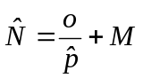 | (1)
where:
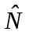 = | the total number of household permits issued,
= | the number of permits issued and returned by households before the first reminder letter, but with no vendor card (the “orphan permits”),
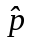 = | 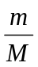= | the response rate before the first reminder letter among households with vendor cards,
= | the number of permits returned before the first reminder letter mailing with vendor cards,
 = | the total number of permits with vendor cards.
With variance estimated as:
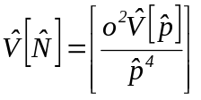 , | (2)
where,
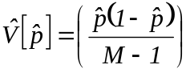 .
The estimated number of permits issued will then be divided in 4 groups:
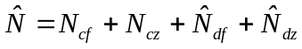 , | (3)
where:
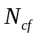= | the number of compliant households who reported fishing,
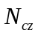= | the number of compliant households who reported they did not fish,
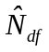= | 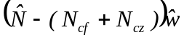,
 | the estimated number of non-compliant households who fished,
 | where 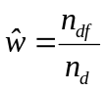
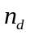 = the number of non-compliant households responding to the last reminder,
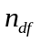 = the number of non-compliant households who responded to the last reminder and reported fishing, and
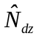= | the estimated number of non-compliant households who reported they did not fish.
 | 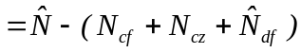
Harvest for each species or participation for each site is estimated by the following procedure (with subscripts denoting parameter of estimation deleted for simplicity):
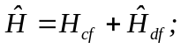 | (4)
where:
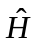 = | estimated total harvest or participation;
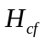 = | harvest or participation reported by compliant households, and;
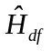 = | estimated harvest by non-compliant households = 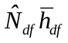
where 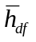 = the mean harvest or participation per household for non-compliant households that fished
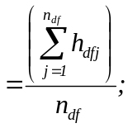
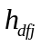 = | reported harvest by household j that responded, was non-compliant, and fished
= | the number of households that responded, were non-compliant, and fished.

Variance will be calculated as (Goodman 1960):
, | (5)
where:
, | (6)
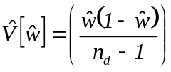,
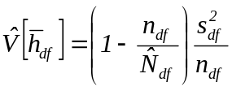 , and | (7)
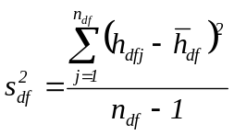 . | (8)
Standard errors are simply the square root of the variance estimate.

SCHEDULES AND REPORTS
The following milestones must be met to keep the survey on schedule:
- 2005 permit designed and reviewed by Analyst Programmer assigned to this project by March 9, 2005.
- Permits for 2005 printed and delivered to the office by the last week of March, 2005.
- Permits bundled into groups for each office or vendor by the first week of April. Permits for Anchorage vendors are distributed to vendors by RTS staff and the project biologist. Permits for Mat-Su and Kenai Peninsula vendors are distributed by the area offices and/or the project leader.
- Vendor portions of 2005 permits will be collected from license vendors by August 31, 2005.
- All permit holder identification information from the top copies of the permits will be keypunched by September 10, 2005.
- Harvest and participation information from initial respondents will be keypunched by September 16, 2005.
- Non-respondents will be identified and first reminder letter mailed by September 29, 2005.
- Non-respondents from the first mailing will be identified and second reminder letter mailed to the non-respondents by October 27, 2005.
- License numbers and harvest and participation information from respondents to the second reminder will be keypunched by November 19, 2005.
- Final, clean data set, along with metadata and log of the edits will be given to project leader by December 10, 2005.
- Annual summary tables of participation and harvest will be available for management purposes.
- A Fisheries Data Series (FDS) report will be published prior to the January 2008 Upper Cook Inlet Board of Fisheries meeting with estimates of participation and harvest from the personal use fisheries in 2004-2006.

LITERATURE CITED
Alaska Administrative Code. Fish and Game Laws and Regulations, 2004-2005 edition. LexisNexis, Charlottesville, VA.
Goodman, L. A. 1960. On the exact variance of products. Journal of the American Statistical Association 55: 708-713.
Nelson, D., D. Athons, P. Berkhahn, and S. Sonnichsen 1999. Area management report for the recreational fisheries of the Kenai Peninsula, 1995-1997. Alaska Department of Fish and Game, Fishery Management Report No. 99-3, Anchorage.
Reimer, A.M. and D. Sigurdsson. 2004. Upper Cook Inlet personal use salmon fisheries, 1996-2003. Alaska Department of Fish and Game, Fishery Data Series Report No. 04-31, Anchorage.

Table 1.-Number of permits issued and response rates by mailing, 2000-2004.
 |  | 2000 | 2001 | 2002 | 2003 | 2004
Permits Issued (estimated) |  | 16,107 | 16,915 | 17,568 | 19,110 | 21,910
Voluntary Returnsa |  | 50.1% | 50.3% | 50.9% | 50.8% | 48.6%
Returned after first reminder |  | 24.6% | 23.0% | 18.6% | 19.0% | 9.5%
Returned after second reminder |  | 9.6% | 11.7% | 12.4% | 13.4% | 22.9% ^{b}
Non-response |  | 15.7% | 14.9% | 18.1% | 16.7% | 19.0%
Total |  | 100.0% | 99.9% | 100.0% | 99.9% | 100.0%

a Voluntary households are those that voluntarily returned their completed permits without being mailed a reminder letter.
^{b} The hiatus between courtesy reminders was not strictly followed by the mailing service in 2004.

Table 2. Salmon harvests, standard errors and relative precision in Upper Cook Inlet Personal Use Fisheries, 2000-2004.
Effort | ₂₀₀₀ |  |  | ₂₀₀₁ |  |  | ₂₀₀₂ |  |  | ₂₀₀₃ |  |  | ₂₀₀₄ |  |  | ₀₀₋₀₄
_{Fishery} | _{Days} | _{SE} | _{RP}ª | _{Days} | _{SE} | _{RP a} | _{Days} | _{SE} | _{RP} ª | _{Days} | _{SE} | _{RP a} | _{Days} | _{SE} | _{RP} ª | _{Average}
_{Kenai Dipnet} | _{12,354} | ₆₉ | _{0.01} | _{14,772} | ₆₆ | _{0.01} | _{14,840} | ₇₉ | _{0.01} | _{15,263} | ₅₀ | _{0.01} | _{18,513} | ₃₅ | _{0.01} | _{15,148}
_{Kasilof Dipnet} | _{2,622} | ₃₆ | _{0.03} | _{3,382} | ₃₇ | _{0.02} | _{4,020} | ₃₈ | _{0.02} | _{3,874} | ₂₈ | _{0.01} | _{4,432} | ₁₉ | _{0.01} | _{3,666}
_{Kasilof Gillnet} | _{1,252} | ₂₃ | _{0.04} | _{1,001} | ₂₀ | _{0.04} | _{1,025} | ₁₆ | _{0.03} | _{1,206} | ₁₇ | _{0.03} | _{1,272} | ₁₀ | _{0.02} | _{1,151}
_{Fish Ck. Dipnet} ^{b} | _{1,054} | ₂₅ | _{0.05} | ₁₃₁ | ₇ | _{0.10} | ₀ | ₀ |  | ₀ | ₀ |  | ₀ | ₀ |  | ₅₉₃
_{Total} | _{17,282} | ₈₅ | _{0.01} | _{19,286} | ₇₉ | _{0.01} | _{19,885} | ₈₉ | _{0.01} | _{20,343} | ₆₀ | _{0.01}

Sockeye Salmon | ₂₀₀₀ |  |  | ₂₀₀₁ |  |  | ₂₀₀₂ |  |  | ₂₀₀₃ |  |  | ₂₀₀₄ |  |  | ₀₀₋₀₄
_{Fishery} | _{Harvest} | _{SE} | _{RP}ª | _{Harvest} | _{SE} | _{RP} ª | _{Harvest} | _{SE} | _{RP} ª | _{Harvest} | _{SE} | _{RP} ª | _{Harvest} | _{SE} | _{RP} ª | _{Average}
_{Kenai Dipnet} | _{98,262} | ₇₅₂ | _{0.015} | _{150,766} | ₉₀₉ | _{0.012} | _{180,028} | ₈₄₄ | _{0.009} | _{223,580} | ₈₉₁ | _{0.008} | _{262,831} | ₅₈₃ | _{0.004} | _{183,093}
_{Kasilof Dipnet} | _{23,877} | ₄₀₃ | _{0.033} | _{37,612} | ₅₀₅ | _{0.026} | _{46,769} | ₅₃₀ | _{0.022} | _{43,870} | ₄₄₀ | _{0.020} | _{48,315} | ₂₅₉ | _{0.011} | _{40,089}
_{Kasilof Gillnet} | _{14,774} | ₂₇₅ | _{0.036} | _{17,201} | ₃₉₄ | _{0.045} | _{17,980} | ₂₇₄ | _{0.030} | _{15,706} | ₂₇₇ | _{0.035} | _{25,417} | ₂₀₃ | _{0.016} | _{18,216}
_{Fish Ck. Dipnet} ^{b} | _{6,925} | ₂₁₁ | _{0.060} | ₄₃₆ | ₄₀ | _{0.18} | ₀ | ₀ |  | ₀ | ₀ |  | ₀ | ₀ |  | _{1,472}
_{Unrecorded Site} | _{5,429} | ₂₇₄ | _{0.099} | _{12,673} | ₃₈₀ | _{0.059} | _{14,846} | ₃₅₃ | _{0.047} | _{15,675} | ₂₄₇ | _{0.031} | _{13,527} | ₁₇₉ | _{0.026} | _{12,430}
_{Total} | _{149,267} | ₉₆₁ | _{0.013} | _{218,688} | _{1,176} | _{0.011} | _{259,623} | _{1,092} | _{0.008} | _{298,831} | _{1,061} | _{0.007} | _{350,091} | ₆₇₈ | _{0.004} | _{255,300}

Chinook Salmon | ₂₀₀₀ |  |  | ₂₀₀₁ |  |  | ₂₀₀₂ |  |  | ₂₀₀₃ |  |  | ₂₀₀₄ |  |  | ₀₀₋₀₄
_{Fishery} | _{Harvest} | _{SE} | _{RP} ª | _{Harvest} | _{SE} | _{RP} ª | _{Harvest} | _{SE} | _{RP} ª | _{Harvest} | _{SE} | _{RP} ª | _{Harvest} | _{SE} | _{RP} ª | _{Average}
_{Kenai Dipnet} | ₄₁₀ | ₁₈ | _{0.086} | ₆₃₈ | ₁₅ | _{0.046} | ₆₀₆ | ₁₁ | _{0.036} | _{1,016} | ₁₈ | _{0.035} | ₇₉₂ | ₇ | _{0.017} | ₆₉₂
_{Kasilof Dipnet} | ₁₃₄ | ₇ | _{0.102} | ₁₃₈ | ₆ | _{0.085} | ₁₀₆ | ₆ | _{0.111} | ₅₇ | ₄ | _{0.138} | ₄₄ | ₃ | _{0.134} | ₉₆
_{Kasilof Gillnet} | ₅₁₄ | ₁₅ | _{0.057} | ₁₇₄ | ₆ | _{0.068} | ₁₉₂ | ₅ | _{0.051} | ₄₀₀ | ₁₃ | _{0.064} | ₁₆₃ | ₄ | _{0.048} | ₂₈₉
_{Fish Ck. Dipnet} ^{b} | ₀ | ₀ |  | ₀ | ₀ |  | ₀ | ₀ |  | ₀ | ₀ |  | ₀ | ₀ |  | ₀
_{Unrecorded Site} | ₄₄ | ₁₃ | _{0.579} | ₁₈₈ | ₁₇ | _{0.177} | ₁₆₆ | ₁₀ | _{0.118} | ₂₃₈ | ₂₅ | _{0.206} | ₉₉ | ₃ | _{0.059} | ₁₄₇
_{Total} | _{1,102} | ₂₈ | _{0.049} | _{1,138} | ₂₄ | _{0.042} | _{1,070} | ₁₇ | _{0.031} | _{1,711} | ₃₄ | _{0.039} | _{1,098} | ₉ | _{0.016} | _{1,224}

Coho Salmon | ₂₀₀₀ |  |  | ₂₀₀₁ |  |  | ₂₀₀₂ |  |  | ₂₀₀₃ |  |  | ₂₀₀₄ |  |  | ₀₀₋₀₄
_{Fishery} | _{Harvest} | _{SE} | _{RP} ª | _{Harvest} | _{SE} | _{RP} ª | _{Harvest} | _{SE} | _{RP} ª | _{Harvest} | _{SE} | _{RP} ª | _{Harvest} | _{SE} | _{RP} ª | _{Average}
_{Kenai Dipnet} | _{1,449} | ₆₂ | _{0.084} | _{1,555} | ₁₀₅ | _{0.132} | _{1,721} | ₆₄ | _{0.073} | _{1,332} | ₆₈ | _{0.100} | _{2,661} | ₆₆ | _{0.049} | _{1,744}
_{Kasilof Dipnet} | _{1,004} | ₁₆ | _{0.031} | ₇₆₆ | ₂₅ | _{0.064} | _{1,197} | ₅₉ | _{0.097} | ₅₉₂ | ₄₉ | _{0.162} | ₆₆₈ | ₂₁ | _{0.062} | ₈₄₅
_{Kasilof Gillnet} | ₉ | ₀ | _{0.000} | ₆ | ₀ | _{0.000} | ₁₂ | ₀ | _{0.000} | ₁₀₇ | ₀ | _{0.000} | ₅₈ | ₁₃ | _{0.439} | ₃₈
_{Fish Ck. Dipnet} ^{b} | ₉₅₈ | ₇₂ | _{0.147} | ₁₈ | ₇ | _{0.762} | ₀ | ₀ |  | ₀ | ₀ |  | ₀ | ₀ |  | ₁₉₅
_{Unrecorded Site218} | ₂₁₈ | ₆₀ | _{0.539} | ₂₉₂ | ₃₀ | _{0.201} | ₃₄₁ | ₂₅ | _{0.144} | ₂₁₉ | ₁₄ | _{0.125} | ₃₆₆ | ₂₅ | _{0.134} | ₂₈₇
_{Total} | _{3,638} | ₁₁₄ | _{0.061} | _{2,637} | ₁₁₂ | _{0.083} | _{3,271} | ₉₁ | _{0.054} | _{2,250} | ₈₅ | _{0.074} | _{3,754} | ₇₅ | _{0.039} | _{3,110}

Chum Salmon | ₂₀₀₀ |  |  | ₂₀₀₁ |  |  | ₂₀₀₂ |  |  | ₂₀₀₃ |  |  | ₂₀₀₄ |  |  | ₀₀₋₀₄
_{Fishery} | _{Harvest} | _{SE} | _{RP} ª | _{Harvest} | _{SE} | _{RP} ª | _{Harvest} | _{SE} | _{RP} ª | _{Harvest} | _{SE} | _{RP} ª | _{Harvest} | _{SE} | _{RP} ª | _{Average}
_{Kenai Dipnet} | ₁₉₃ | ₃₁ | _{0.315} | ₁₅₅ | ₁₉ | _{0.240} | ₅₅₁ | ₃₆ | _{0.128} | ₂₄₉ | ₂₂ | _{0.173} | ₃₈₇ | ₁₂ | _{0.061} | ₃₀₇
_{Kasilof Dipnet} | ₃₄ | ₀ | _{0.000} | ₂₃ | ₀ | _{0.000} | ₁₃₉ | ₇ | _{0.099} | ₃₀ | ₁ | _{0.065} | ₉₀ | ₅ | _{0.109} | ₆₃
_{Kasilof Gillnet} | ₁₀ | ₀ | _{0.000} | ₇ | ₅ | _{1.400} | ₁₃ | ₄ | _{0.603} | ₄ | ₀ | _{0.000} | ₀ | ₀ |  | ₇
_{Fish Ck. Dipnet} ^{b} | ₂₉ | ₃ | _{0.203} | ₁ | ₀ | _{0.000} | ₀ | ₀ |  | ₀ | ₀ |  | ₀ | ₀ |  | ₆
_{Unrecorded Site} | ₂₄ | ₁₅ | _{1.225} | ₉₀ | ₃₄ | _{0.740} | ₅₄ | ₈ | _{0.290} | ₈₈ | ₉ | _{0.200} | ₂₅ | ₄ | _{0.314} | ₅₆
_{Total} | ₂₉₀ | ₃₅ | _{0.234} | ₂₇₆ | ₃₉ | _{0.279} | ₇₅₇ | ₃₈ | _{0.098} | ₃₇₁ | ₂₄ | _{0.126} | ₅₀₂ | ₁₄ | _{0.055} | ₄₃₉

Pink Salmon | ₂₀₀₀ |  |  | ₂₀₀₁ |  |  | ₂₀₀₂ |  |  | ₂₀₀₃ |  |  | ₂₀₀₄ |  |  | ₀₀₋₀₄
_{Fishery} | _{Harvest} | _{SE} | _{RP} ª | _{Harvest} | _{SE} | _{RP} ª | _{Harvest} | _{SE} | _{RP} ª | _{Harvest} | _{SE} | _{RP} ª | _{Harvest} | _{SE} | _{RP} ª | _{Average}
_{Kenai Dipnet} | _{1,457} | ₇₅ | _{0.101} | _{1,326} | ₃₇ | _{0.055} | _{5,662} | ₁₀₂ | _{0.035} | _{1,647} | ₉₈ | _{0.117} | _{2,103} | ₂₇ | _{0.025} | _{2,439}
_{Kasilof Dipnet} | ₈₄₁ | ₃₉ | _{0.091} | ₃₀₇ | ₁₄ | _{0.089} | _{1,862} | ₇₃ | _{0.077} | ₂₈₆ | ₂₁ | _{0.144} | ₃₉₆ | ₁₅ | _{0.074} | ₇₃₈
_{Kasilof Gillnet} | ₁₇ | ₂ | _{0.231} | ₁₁ | ₀ | _{0.000} | ₃₀ | ₂ | _{0.131} | ₉ | ₀ | _{0.000} | ₆ | ₁ | _{0.327} | ₁₅
_{Fish Ck. Dipnet} ^{b} | ₈₃ | ₁₂ | _{0.283} | ₂ | ₀ | _{0.000} | ₀ | ₀ |  | ₀ | ₀ |  | ₀ | ₀ |  | ₁₇
_{Unrecorded Site} | ₈₄ | ₁₁ | _{0.257} | ₁₇₅ | ₂₄ | _{0.269} | ₉₁₆ | ₈₁ | _{0.173} | ₁₄₀ | ₉ | _{0.126} | ₂₁₀ | ₃₂ | _{0.093} | ₃₀₅
_{Total} | _{2,482} | ₈₆ | _{0.068} | _{1,821} | ₄₆ | _{0.050} | _{8,470} | ₁₄₉ | _{0.035} | _{2,082} | ₁₀₁ | _{0.095} | _{2,715} | ₃₂ | _{0.023} | _{3,514}
ª Relative Precision (SE * α / estimate)
^{b} Fishery restricted to 3 days in 2001 and closed in 2002-2004.

Appendix A - 2005 Upper Cook Inlet personal use Salmon Fishing Permit
Appendix A1.- 2005 Upper Cook Inlet personal use salmon permit.
Vendor Copy |  |  |  |  |  |  |  |  |  |  | Permit Number: |  |  |  |  | 05-
2005 Upper Cook Inlet Personal Use Salmon Fishery
Last Name |  |  |  |  |  |  |  |  |  | First Name |  |  |  |  |  |  |  | Middle Initial
Mailing Address
City |  |  |  |  |  |  |  | State |  |  |  |  |  | Zip Code
Phone Number: (907)
Total Number of Household members: |  | Total Household Salmon Harvest Limit: |  |  |  |  |  |  | You are allowed 25 salmon for the head-of-household, and 10 salmon for each additional household member. This is your salmon limit for the entire 2005 season.  In addition, each household permit is allowed 10 flounders.
2005 Alaska Resident Fishing License Number: |  |  |  |  |  |  |  |  |  |  |  |  | Alaska Driver’s License  Number:
I have read and understand the permit requirements (listed on the back) and agree to return this permit to
the Alaska Department of Fish and Game by August 15, 2005. Failure to return this permit is a violation of
5 AAC 77.015(c) and subject to a $200 fine and loss of your personal use fishing privileges.

Signature of Permit Holder |  | Date
Vendor Signature | Vendor Number:

 |  |  |  |  |  |  |  |  | Permit Number: |  |  |  | 05-
2005 Upper Cook Inlet Personal Use Salmon Fishery Permit

☆ TIPS OF THE TAILS MUST BE REMOVED AND HARVEST MUST BE RECORDED IMMEDIATELY; PRIOR TO LEAVING THE FISHING SITE ☆
Last Name |  |  |  |  | First Name |  |  |  |  |  |  | Middle Initial
Names of Other Household Members
Total Number of Household Members: |  |  | Total Household Salmon Harvest Limit: |  |  |  | You are allowed 25 salmon for the head-of-household, and 10 salmon for each additional household member. This is your salmon limit for the entire 2005 season.  In addition, each household permit is allowed 10 flounders.
This permit is for dipnetting at the mouth of the Kasilof and Kenai rivers and Fish Creek (near Wasilla) and for gillnetting near the mouth of the Kasilof River in 2005. You must have this permit with you while you are fishing, and you must record your harvest before you leave the fishing site. Check the Sport Fishing Regulation Summary for legal times, gear and species restrictions.
Check this box if no one in your household fished

Report all days fished and all fish harvested. Record every day you fish, even those days when you didn’t catch anything.
Date | Location (Circle one) |  |  |  |  | RED |  | chum |  | King | COHO |  |  | Pink | Flounder
m / Day | Kenai River, Fish Creek, Kasilof River
m / Day | Kenai River, Fish Creek, Kasilof River
m / Day | Kenai River, Fish Creek, Kasilof River
m / Day | Kenai River, Fish Creek, Kasilof River
m / Day | Kenai River, Fish Creek, Kasilof River
m / Day | Kenai River, Fish Creek, Kasilof River
m / Day | Kenai River, Fish Creek, Kasilof River
*Fisheries are: Kenai River Dip Net, Fish Creek Dip Net, Kasilof River Gill Net and Kasilof River Dip net.
Return this permit to Fish and Game by August 15 2005. You must return your permit even if you did not fish.

Appendix B -Reminder letter to be mailed to nonrespondents
Appendix B1.-Reminder letter to be mailed to nonrespondents.

PRST STD
U.S. Postage PAID
Anchorage, AK

STATE OF ALASKA

DEPARTMENT OF FISH & GAME
Personal Use Salmon Permits
333 raspberry road
Anchorage AK 99518-1599

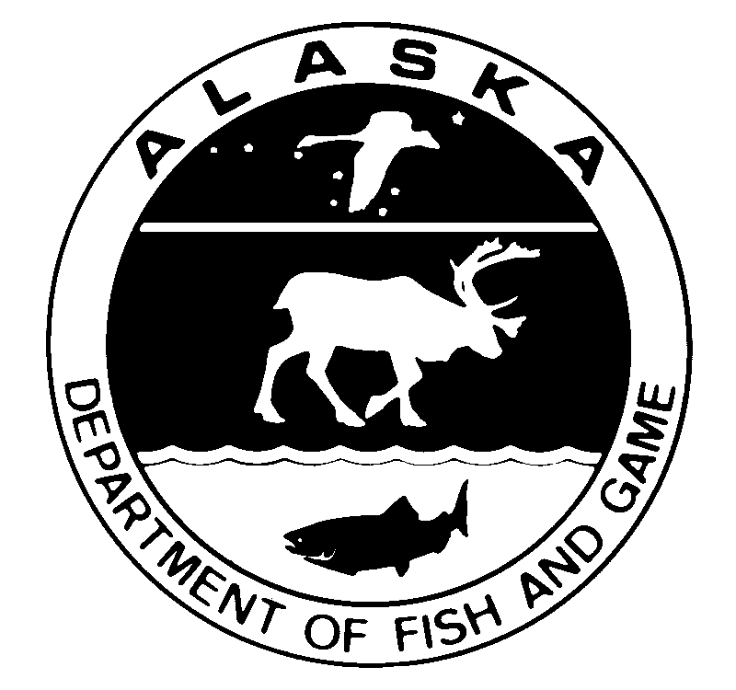
2005 Upper Cook Inlet Personal Use Salmon Fishery-Reminder

Dear Permit Holder,
Our records indicate that you have not returned your 2005 Upper Cook Inlet Personal Use Salmon permit. Please take a few minutes to return the original permit or use the form below. Your harvest information is vital to continuing salmon management and personal use fishing opportunities in the future.
Remember that you must return your permit, even if you did not fish. Failure to return your permit is a violation of 5 AAC 77.015(c) and subject to a $200 fine and loss of your future personal use fishing privileges.
Total Number of Household members: |  |  | Total Household Salmon Harvest Limit: |  |  | You are allowed 25 salmon for the head-of-household, and 10 salmon for each additional household member. This is your limit for the entire 2005 season.  In addition, each household permit is allowed 10 flounders.
Check this box if no one in your household fished
Report all days fished and all fish harvested. Record every day you fished, including days when you did not harvest any fish.
Date | Location (Circle One) |  |  |  | RED |  | CHUM | KING | COHO | PINK | Flounder
m / Day | Kenai River, Fish Creek, Kasilof River
m / Day | Kenai River, Fish Creek, Kasilof River
m / Day | Kenai River, Fish Creek, Kasilof River
m / Day | Kenai River, Fish Creek, Kasilof River
m / Day | Kenai River, Fish Creek, Kasilof River
m / Day | Kenai River, Fish Creek, Kasilof River
m / Day | Kenai River, Fish Creek, Kasilof River
*Fisheries are: Kenai River Dip Net, Kasilof River Dip net, Fish Creek Dip Net, Kasilof River Gill Net
YOU MUST RETURN YOUR PERMIT EVEN IF YOU DID NOT FISH.

Place
first-class
Postage
Here


STATE OF ALASKA

DEPARTMENT OF FISH & GAME
Personal Use Salmon Permits
333 raspberry road
Anchorage AK 99518-1599

STATE OF ALASKA

DEPARTMENT OF FISH & GAME

Personal Use Salmon Permits
333 raspberry road
Anchorage AK 99518-1599

Appendix C - Cook Inlet personal use Fishing Regulations, 2005

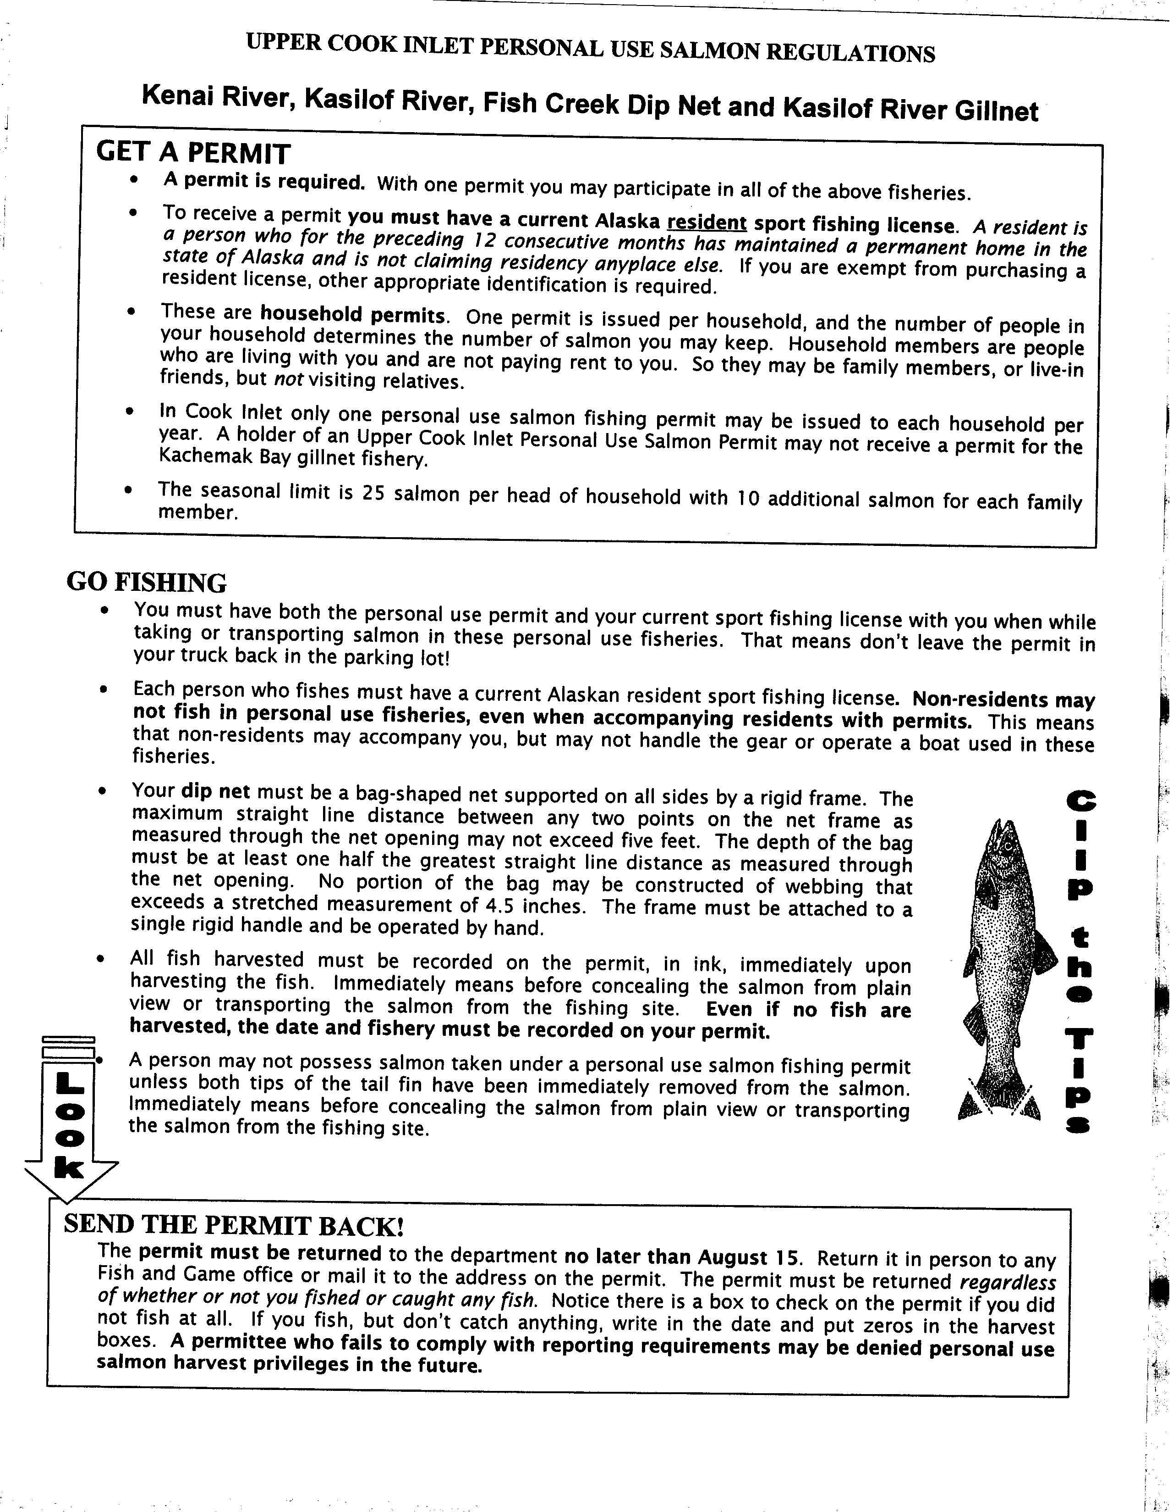

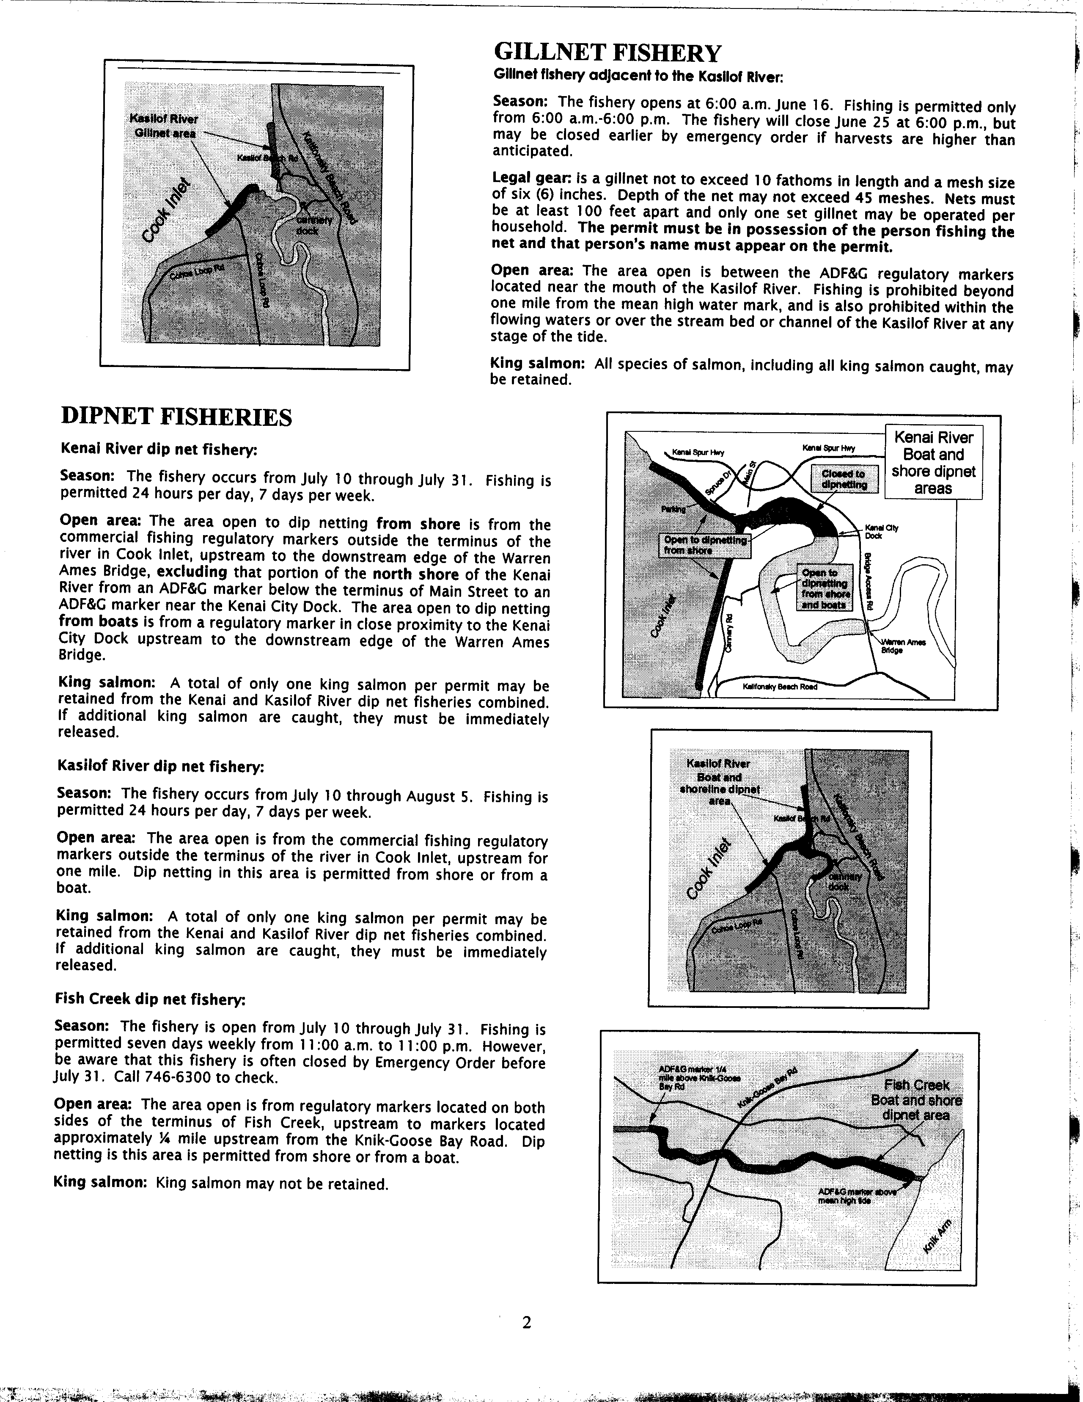

Appendix d - Keypunching instructions

2005 Cook Inlet Personal Use Salmon

Data Entry Instructions

Overview
The Cook Inlet Personal Use Salmon Project is key punched by the Anchorage ADF&G Sport Fish RTS Data Entry staff using an Intranet based application. The application consists of HTML pages written in Cold Fusion that allow entry, editing and deletion of permit holder and harvest information. Access to this application is through the ADFG Intranet and restricted based on user ID as to what functions are allowed. Data from the entry application goes directly into two MS SQL “raw” tables - one for the permit holder information (CISLPMXX) and one for the harvest information (CISLHVXX). These tables are part of the CISALXX database.

Permit Holder Entry
Access to the Permit Entry system is through the ADF&G Intranet Site Index Main Menu Permits section:

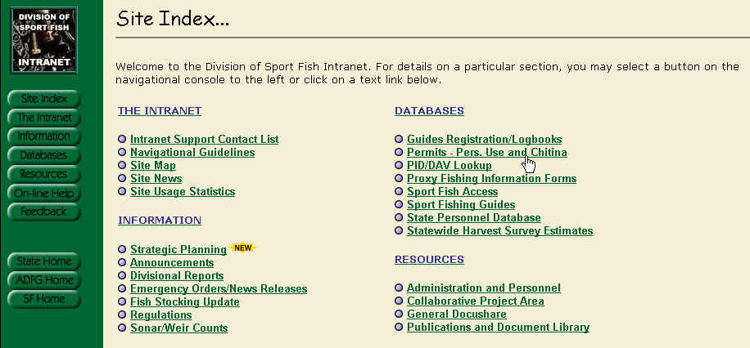

Once selected, you should see the following screen:
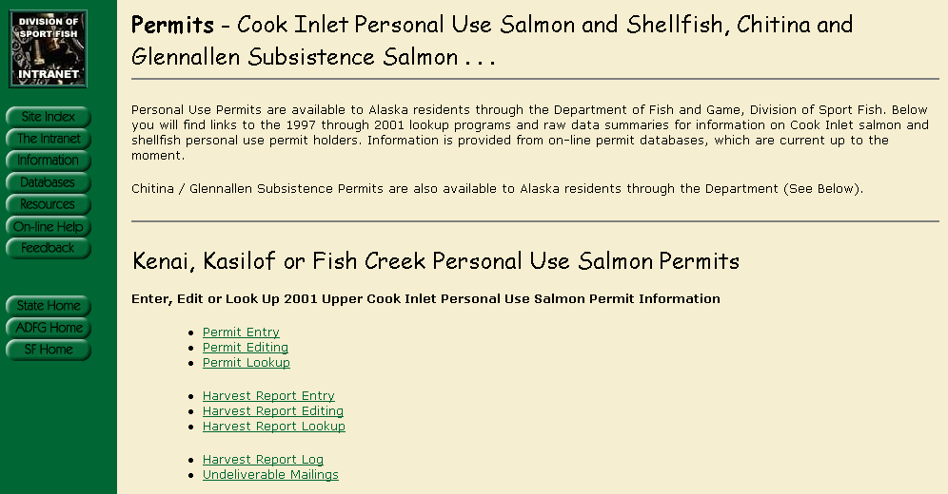

Selecting Permit Entry will bring up a screen in which you enter the Permit Number that is stamped on the bottom right of the Permit itself and whatever ID number that is written in the ADL / ID box on the permit. This number will be searched through the previous years database, PID database and Sports License Database (in that order) to try and fill the applicable fields.

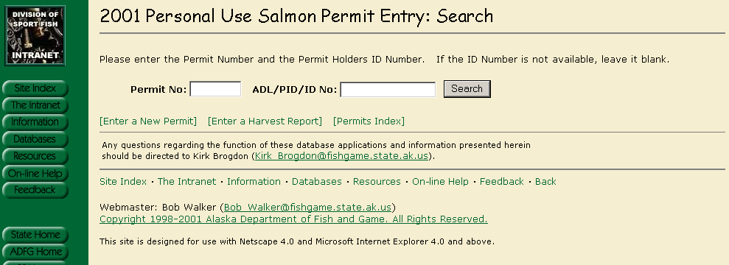

Note that the year (2005) and the addition of flounder are the only changes in data entry structure.

If a record is found, you will see a display showing the Name and ID number as well as an indication as to what Database the information was found. If the Information appears to be the same person that you are entering for, click on any field in the box to auto fill the permit with as much information as possible.

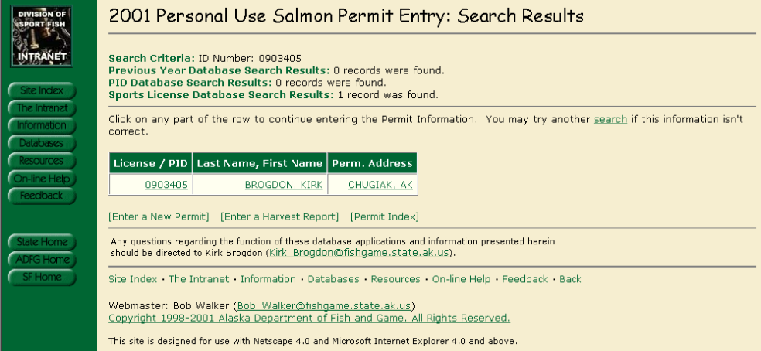
Which should bring up the following screen in which you can complete and/or edit based on the written permit. If there is no information available then the same screen will come up but all of the fields will be blank.
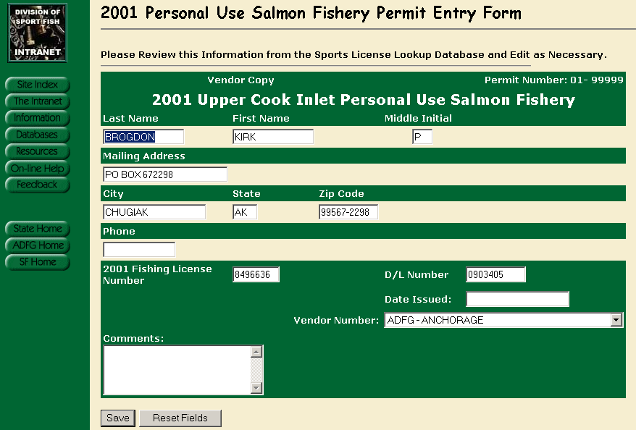

Once filled out, click on the Save button and you should see the following:

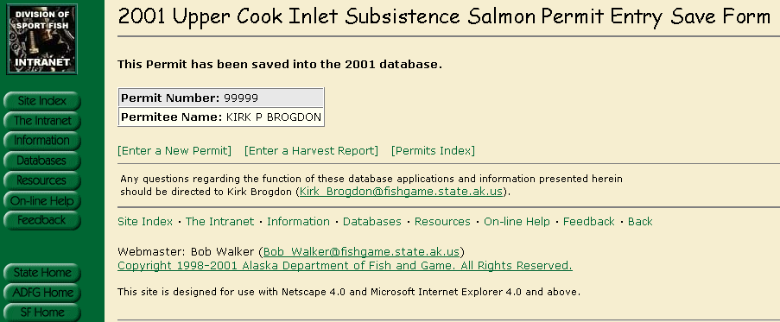

Miscellaneous Permit Entry Notes

Required Fields:
- Date Issued
If the Date Issued is left blank, the Entry Clerk is prompted that it must be filled in and to enter ‘01/01/yyyy’ if the actual permit does not have an issued date on it.

Permit Editing

From the same screen that you select Permit Entry, there is a link for Permit Editing. When selected, you should see a similar screen as the Entry screen plus there will be check boxes for Did Not Fish, Blank Report and No Success.

Permit Lookup

From the same screen that you select Permit Entry, there is a link for Permit Lookups. This screen will display all the Permit Information but will not allow any edits or deletions. There is also a link to display the actual scanned image of a returned Harvest Report.

Harvest Report Entry
From the same screen that you select Permit Entry, there is a link for Harvest Reporting. When selected, you should see the following screen:
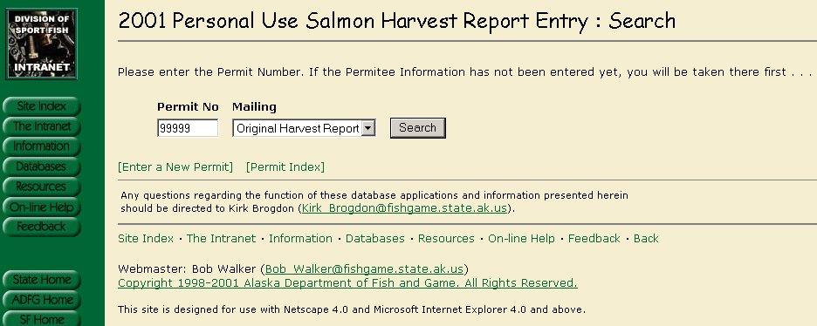
Enter the Permit Number and select the Mailing from the Drop Down list – The default is the original. You should see the following after clicking on Search:
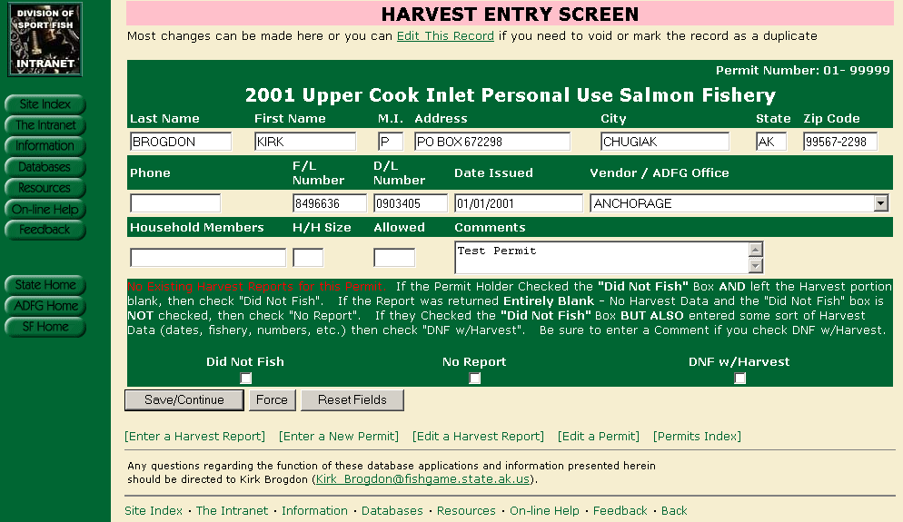

At this point, you have the opportunity to check the “Did Not Fish”, “No Report” (blank) or “DNF with Harvest” boxes – We often receive harvest reports with the “Did Not Fish” box checked but they also enter Harvest (or attempted harvest) information. From the Harvest Report, enter the Allowable harvest, Household size and Household members if available. You can edit any Permit Info shown if necessary, otherwise click on “Save/Continue”.

You should now be on the following screen:

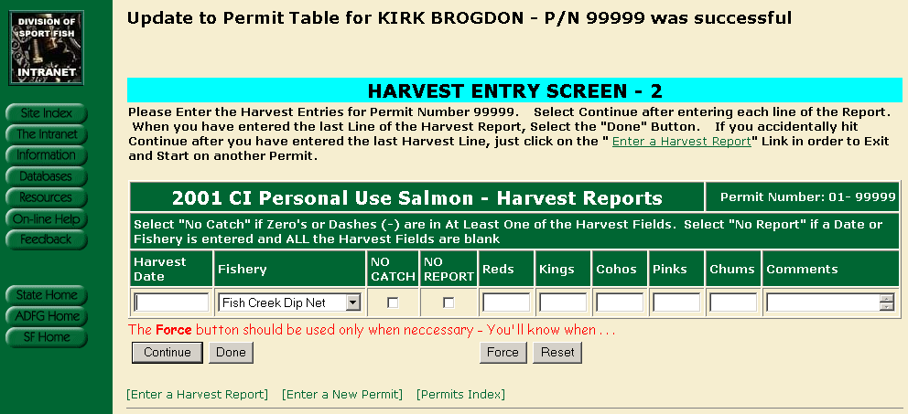

Enter the harvest date as shown on the form. If the date is blank, enter 01/01/1990. If the date shows just the month, enter that month followed by 01/1990. If they have zeros in one or more fields (and nothing else) then that is considered “No Catch” and you should check that box. If they have nothing at all other than a date or location, then that would be considered “No Report” and you should check that box. All of the fields coincide with the actual printed form that the Permit Holder has filled out. Flounders will be added to the data entry structure, prior to data entry in 2005. This screen is built so that you can enter one harvest record (line) at a time. Once you have entered the line, click on continue. Once you do, you should see the following:

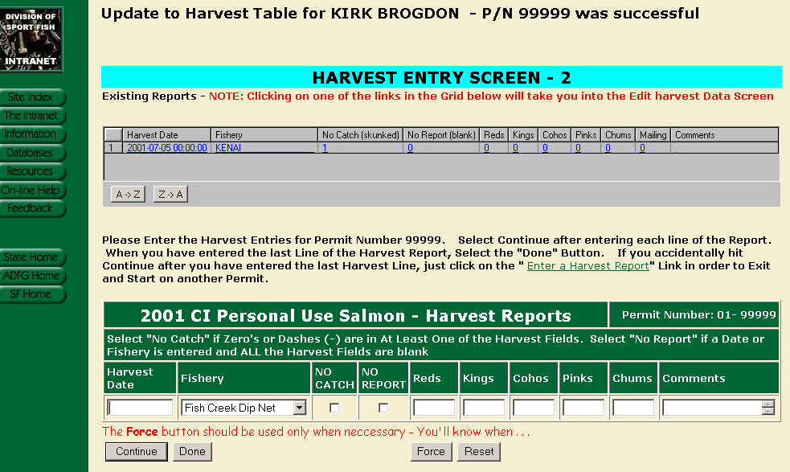

Note that the upper part of the screen shows the harvest entry that you just added (plus any other existing harvest entries for the permit). This upper part of the screen can actually take you into the Harvest edit screen for the permit that you are currently working on (should you realize that you keyed a mistake). Otherwise, keep entering each line of the harvest report until you are on the last one. On the last entry, select “Done” rather than continue (if you click on continue after your last harvest entry, just click on the “Enter a Harvest Report” or one of the other links at the bottom of the page).

Miscellaneous Harvest Report Entry Notes

There are numerous data checks that are performed each time you select “Continue” or “Done” in an attempt to alleviate keying errors. Examples are:

- No harvest numbers entered but “No Catch” or “No Report” is not selected
- “No Catch” or “No Report” is selected but there is a value in one of the harvest fields.
- If any one line totals more than the allowed harvest value

Examples 1 and 2 cannot occur and must be changed. Example 3 could be an actual representation of what is reported and will be accepted if the user submits with the “Force” button. A detailed error message will be presented to the user explaining the problem and how to proceed.

Harvest Reports Returned Before Permit is Entered

It is possible that a permit holder will return their harvest report before an entry is made into the permit table. The following screen will appear if that happens:

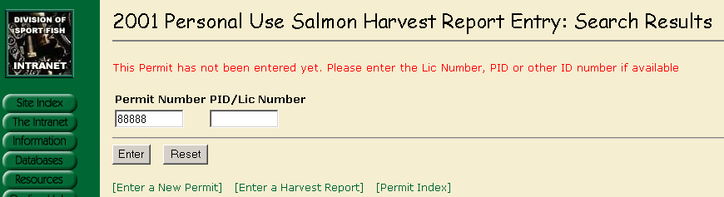

The permit can be entered as normal using the information on the front side of the harvest report. Once that is completed then the harvest report can be entered.

Harvest Report Editing
From the same screen that you select Harvest Report Entry, there is a link for Editing. When selected, you should see the following:
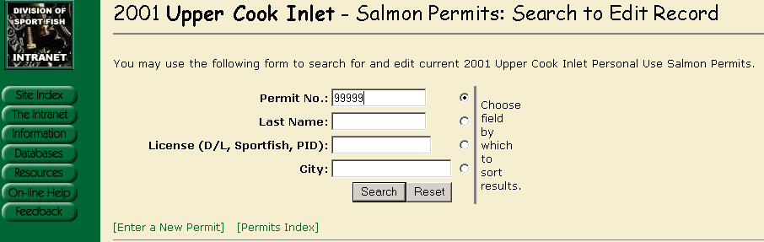
Entering the permit number will bring up the following:
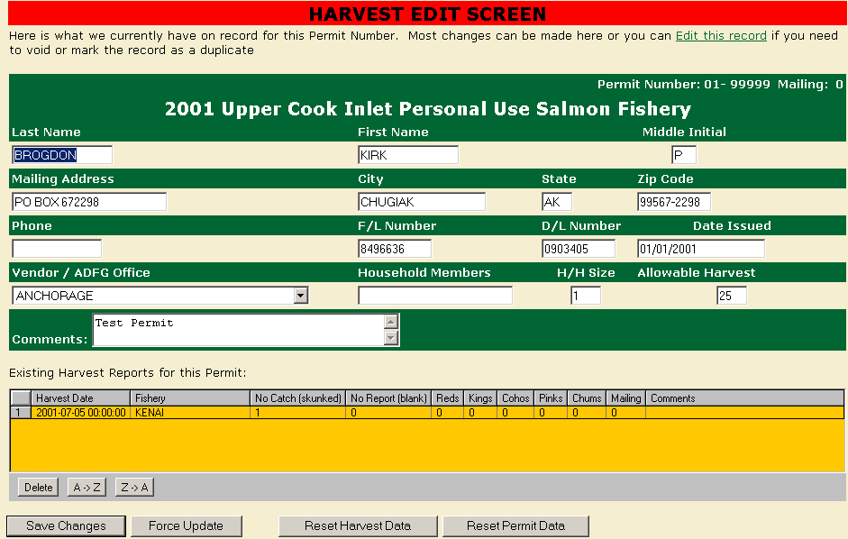
The harvest information can be edited or deleted directly from this screen. If the record needs to be voided, marked as a duplicate or changed to “Did not Fish” or “Blank Report” then the permit itself needs to be edited – not the harvest report. This can be done through the main menu or by using the link at the top of the page (Edit this record).
Note – If harvest data exists then the application will not allow the change to “Did Not Fish” or “Blank Report” until the Harvest Data is deleted.

Appendix E - File Structure for personal use salmon databases

Table and Field Information for Database I:\DP\CISALMXX\CISAL_SQL.DBC
Cook Inlet Personal Use Salmon Permit Process - Corrected and Final Data
02/12/2004 - kpbrogdon

Respondent Harvest Table:

Table: CISLHVXXC
Number of records:
Num Field Name Type Width Dec Nulls Default
1 HVRECID I 4 0 No
2 PERMITNO I 4 0 No
3 NOCATCH L 1 0 No
4 NOHRVRPT L 1 0 No
5 HARVDATE T 8 0 Yes
6 RED I 4 0 No
7 KING I 4 0 No
8 COHO I 4 0 No
9 PINK I 4 0 No
10 CHUM I 4 0 No
11 FISHERY C 20 0 No
12 KEYDATE T 8 0 No
13 KEYID C 16 0 No
14 YEAR I 4 0 No
15 MAILING I 4 0 No
16 EDITED L 1 0 No
17 COMMENTS C 20 0 Yes
-----
113

Additional Field Information For Corrected Harvest Table CISLHVXXC:

HVRECID
Comment: Unique Harvest Record ID as copied from the Raw Harvest
Table

PERMITNO
Comment: Permit Holders Permit Number.

NOCATCH
Comment: Flag indicating that an unsuccessful attempt was made on
this particular day.

NOHRVRPT
Comment: A date or fishery was indicated but all harvest fields are
blank - if zeros or dashes are shown, then this would be a
nocatch.

HARVDATE
Comment: Date that the actual Harvest or attempted harvest took
place.

RED
Comment: Total Red salmon harvested on this day

KING
Comment: Total King salmon harvested on this day

COHO
Comment: Total Coho salmon harvested on this day

PINK
Comment: Total Pink salmon harvested on this day

CHUM
Comment: Total Chum salmon harvested on this day

FISHERY
Comment: Valid Fishery - Choices are Kenai, Kasilof or Fish Creek.
All others are recorded as "Unknown"

KEYDATE
Comment: Date that the Harvest report was keyed by Data Entry

KEYID
Comment: Key ID of Data Entry clerk that enters the Harvest Report.

YEAR
Comment: Fishing Year that the Permit is valid for.

MAILING
Comment: Mailing value of the Harvest Report. This can be 0, 1 or 2.
If harvest data is received on different mailings with
identical Harvest

EDITED
Comment: Extraneous field. Not used

COMMENTS
Comment: Misc comments from Data Entry - Any comments enclosed in
[BRACKETS] are programatic changes made during the
conversion process.

Field Information for Corrected Permit Holder Information (XX Pertains to Year)

Respondent Permit Table (Vendor Copy)
Table: CISLPMXXC
Number of records:
Num Field Name Type Width Dec Nulls Default
1 PMRECID I 4 0 No
2 PERMITNO I 4 0 No
3 FIRST_NAME C 15 0 Yes
4 LAST_NAME C 15 0 Yes
5 INITIAL C 1 0 Yes
6 ADLNO C 10 0 Yes
7 LICENSE_NO C 7 0 Yes
8 ADDRESS C 30 0 Yes
9 CITY C 30 0 Yes
10 STATE C 2 0 Yes
11 ZIPCODE C 10 0 Yes
12 PHONE C 13 0 Yes
13 HHMEMBERS C 50 0 Yes
14 FAMILYSI I 4 0 Yes
15 ALLOWED I 4 0 Yes
16 BLANKRPT L 1 0 No
17 NOTFISH L 1 0 No
18 OFFICE C 20 0 Yes
19 DUPPREF I 4 0 Yes
20 KEYDATE T 8 0 Yes
21 KEYID C 15 0 Yes
22 DATEISS T 8 0 Yes
23 MAILING I 4 0 No
24 STATUS C 3 0 No
25 COMMENTS C 50 0 Yes
26 YEAR I 4 0 No
-----
321

Additional Field Information For Corrected Permit Holder Information CISLPMXXC:

PMRECID
Comment: Unique Record ID from the Raw Permit Table

PERMITNO
Comment: Unique Permit Number - Only Permits that responded are
included in the table

FIRST_NAME
Comment: Permit Holders First Name

LAST_NAME
Comment: Permit Holders Last Name

INITIAL
Comment: Permit Holders Middle Initial

ADLNO
Comment: Permit Holders Drivers License Number

LICENSE_NO
Comment: Permit Holders Fishing License Number

ADDRESS
Comment: Permit Holders Street Address

CITY
Comment: Permit Holders Resident City

STATE
Comment: Permit Holders Resident State

ZIPCODE
Comment: Permit Holders Resident Zipcode

PHONE
Comment: Permit Holders Resident Phone Number

HHMEMBERS
Comment: All additional Household Members that are eligible to fish
under this Permit

FAMILYSI
Comment: Permit Holders Total Family Size - This value can be
calculated if it is not filled in by the vendor providing
allowable Harvest and/or HHmembers exist. If not, Family
Size and Allowed are set to NULL

ALLOWED
Comment: Permit Holders Allowable Harvest - This value can be
calculated if it is not filled in by the vendor providing
Family Size and/or HHmembers exist. If not, Family Size and
Allowed are set to NULL

BLANKRPT
Comment: Flag indicating that a Harvest Report was received but was
completly blank. No harvest values and the "Did Not Fish"
box was not checked.

NOTFISH
Comment: Flag indicating that a Harvest Report was received and the
"Did Not Fish" box was checked.

OFFICE
Comment: Issuing ADFG Office or licensed Vendor

DUPPREF
Comment: Permit numbers that refer to this permit as the master

KEYDATE
Comment: Date that the Permit was originally keyed into the Raw data
table.

KEYID
Comment: Keyid of the original data entry clerk that entered the
permit into the raw data table.

DATEISS
Comment: Date that the Permit was issued by either an ADFG office or
a licensed vendor

MAILING
Comment: Mailing value that the Permit Holder responded to. Values
are "0" for the Original, "1" for the First , "2" for the
Second Reminder. Not necessarily the same as what was
physically turned in as an Original will often be sent in
after a reminder is recd.

STATUS
Comment: Harvest Report Status for the permit. "N" indicates Did Not
Fish, "U" indicates Unknown (Blank Harvest Report) and "H"
indicates actual Harvest data was received.

COMMENTS
Comment: Misc Comments. Any comments inside of [brackets] notate
programatic changes from the Raw data to the corrected ( ie:
family size and allowable harvest corrections)

YEAR
Comment: Harvest Year that the Permit reflects.

Non Respondent Permit Holder Information (Permits Issued but no Report Returned):

Table: CISLPMXXZ
Number of records: 14418
Num Field Name Type Width Dec Nulls Default
1 PMRECID I 4 0 No
2 PERMITNO I 4 0 No
3 FIRST_NAME C 15 0 Yes
4 LAST_NAME C 15 0 Yes
5 INITIAL C 1 0 Yes
6 ADLNO C 10 0 Yes
7 LICENSE_NO C 7 0 Yes
8 ADDRESS C 30 0 Yes
9 CITY C 30 0 Yes
10 STATE C 2 0 Yes
11 ZIPCODE C 10 0 Yes
12 PHONE C 13 0 Yes
13 HHMEMBERS C 50 0 Yes
14 FAMILYSI I 4 0 Yes
15 ALLOWED I 4 0 Yes
16 BLANKRPT L 1 0 No
17 NOTFISH L 1 0 No
18 OFFICE C 20 0 Yes
19 DUPPREF I 4 0 Yes
20 KEYDATE T 8 0 Yes
21 KEYID C 15 0 Yes
22 DATEISS T 8 0 Yes
23 MAILING I 4 0 No
24 STATUS C 3 0 No
25 COMMENTS C 50 0 Yes
26 YEAR I 4 0 No
-----
321

Field Information should be identical to CISHPMXXC with the
exception that all records are for Non Respondent Permit Holders.
There should be no Harvest Records, Did Not Fish or Blank Reports
for any permits in CISHPMXXZ. Status value is "Z" as opposed to
"H", "N" or "U".

